**Tutorial 35: Router Setup**

We will be cover routing and navigating from one page to another. We need to the package Vue router which goes hand in hand with the core Vue library which will allow us to setup a new routing system.

We will be creating a new Vue project.

**Step 1:** In a folder where you are storing your projects open up a terminal or command prompt and type the command:

vue create web-form

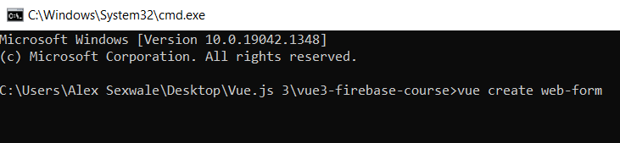

**Step 2:** Select the option “**Manually select features**” by pressing enter

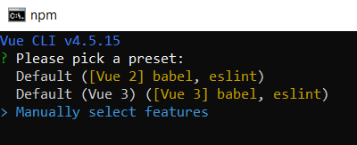

**Step 3:** Remove the “**Linter / Formatter**” option by pressing space and select the Router option then press enter.

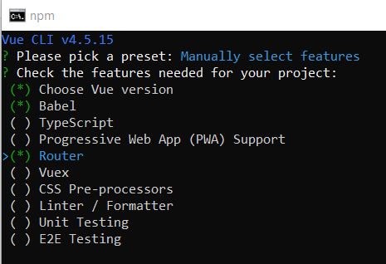

**Step 4:** Select version 3 of Vue.js then press enter.

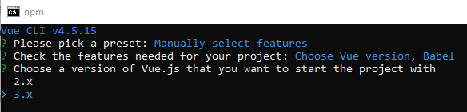

**Step 5:** Type Y then press enter. Selecting history mode will remove the # in the URL. By default Vue includes a # in the URL.

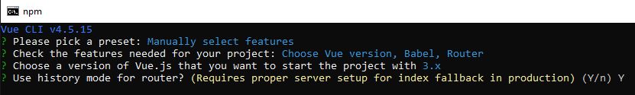

**Step 6:** Select the in dedicated config files then press enter.

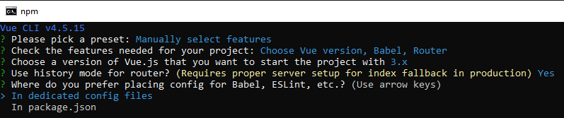

**Step 7:** We don’t want to save the preset so type n and press enter.

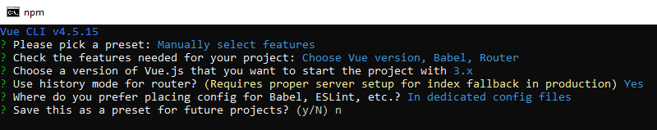

**Step 8:** Change directory to the folder web-form by typing cd web-form and then open the folder in your IDE of your choice. I will be sticking to using VS Code.



Inside the router folder, there is a file called index.js.

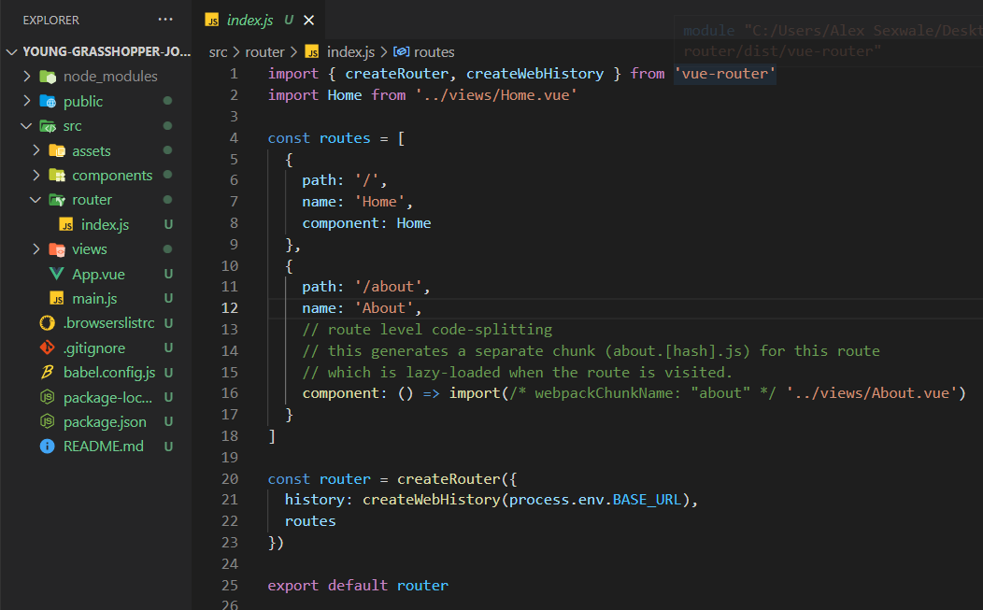

**Path** represents the URL path.

**Name** represents the component name; this helps identify the component.

**Component** represents the imported component.

CreateRouter is imported from the vue-router package. It creates the router instance for the app. The first property passed is the history mode which uses a history API to be able to navigate through pages. The second property passed is the router array, that contains an array of object with path and component names.

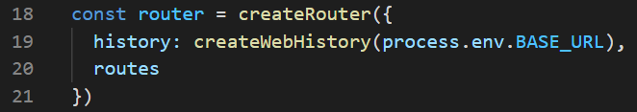

The router is being exported and used in the main.js file to register it in the app so the application uses the router.

The router view is imported the App.vue file and rendered in the template so that the user is able to change routes.

Look at the example below (**Line 6**):

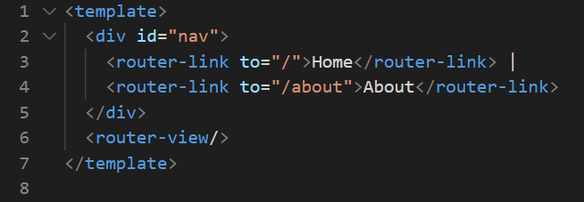

**Step 9:** In the index.js file, change the lazy loading for the about component to have a normal file path, similar to the Home component.

Look at the example below (**Between Line 11 and line 15**):

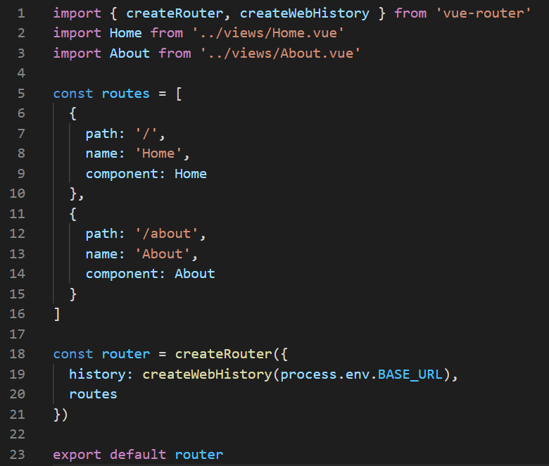

**You can view the code snippets from the** [**vue3-firebase-course**](https://github.com/younggrasshopperza/vue3-firebase-course) **repository under the Tutorial-35 branch**.